Maps of study sites

Nadym site maps
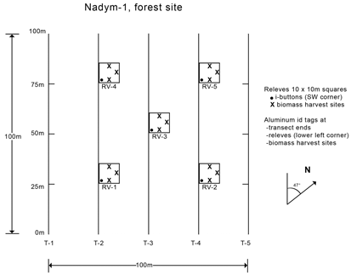
Map of transects and vegetation study plots at Nadym-1.

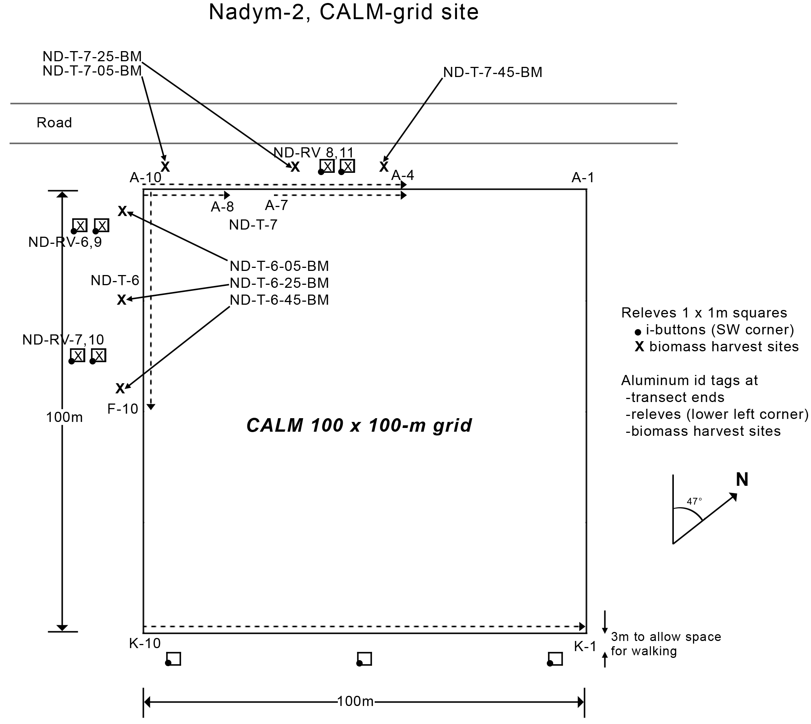
Map of transects and vegetation study plots at Nadym-2.

Laborovaya site maps

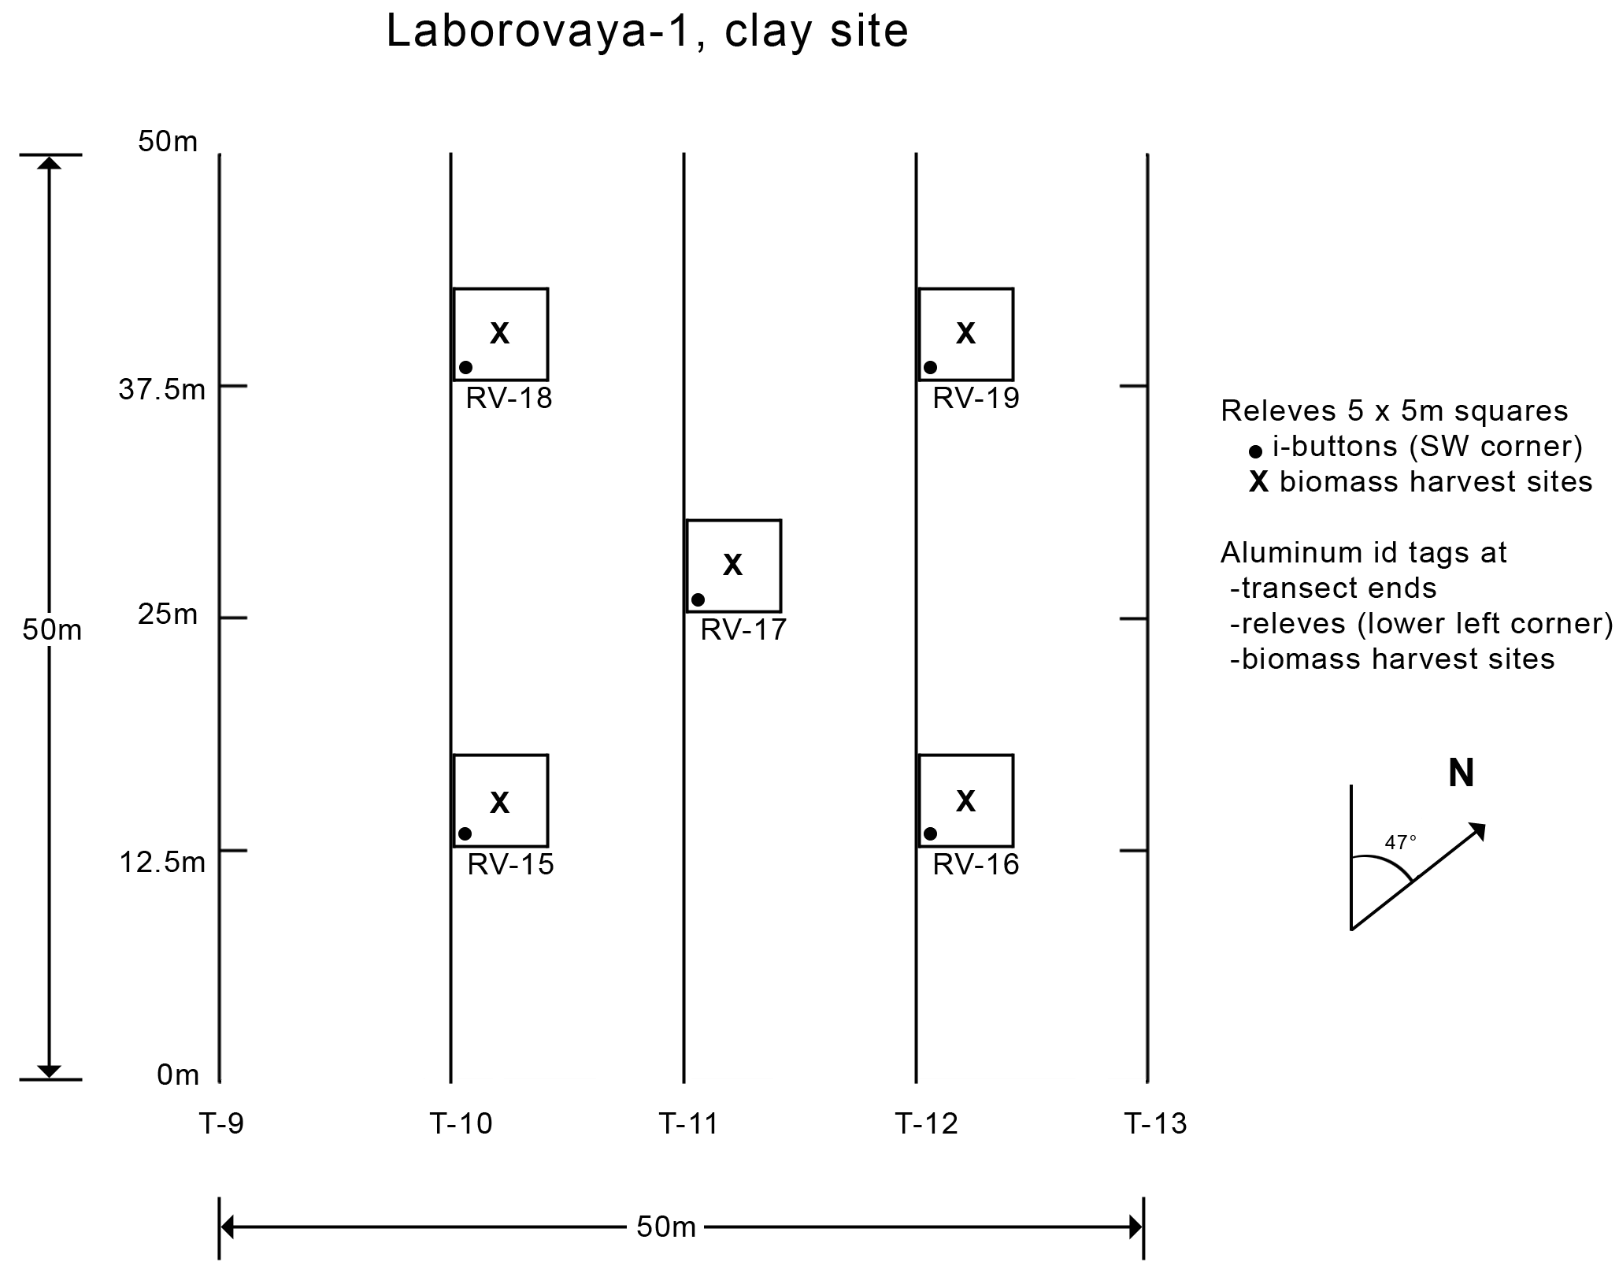
Map of transects and vegetation study plots at Laborovaya-1.

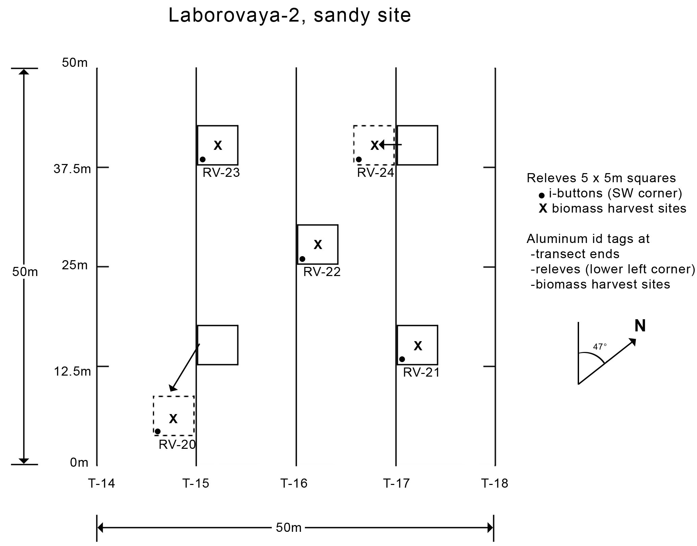
Map of transects and vegetation study plots at Laborovaya-2.

Vaskiny Dachi site maps

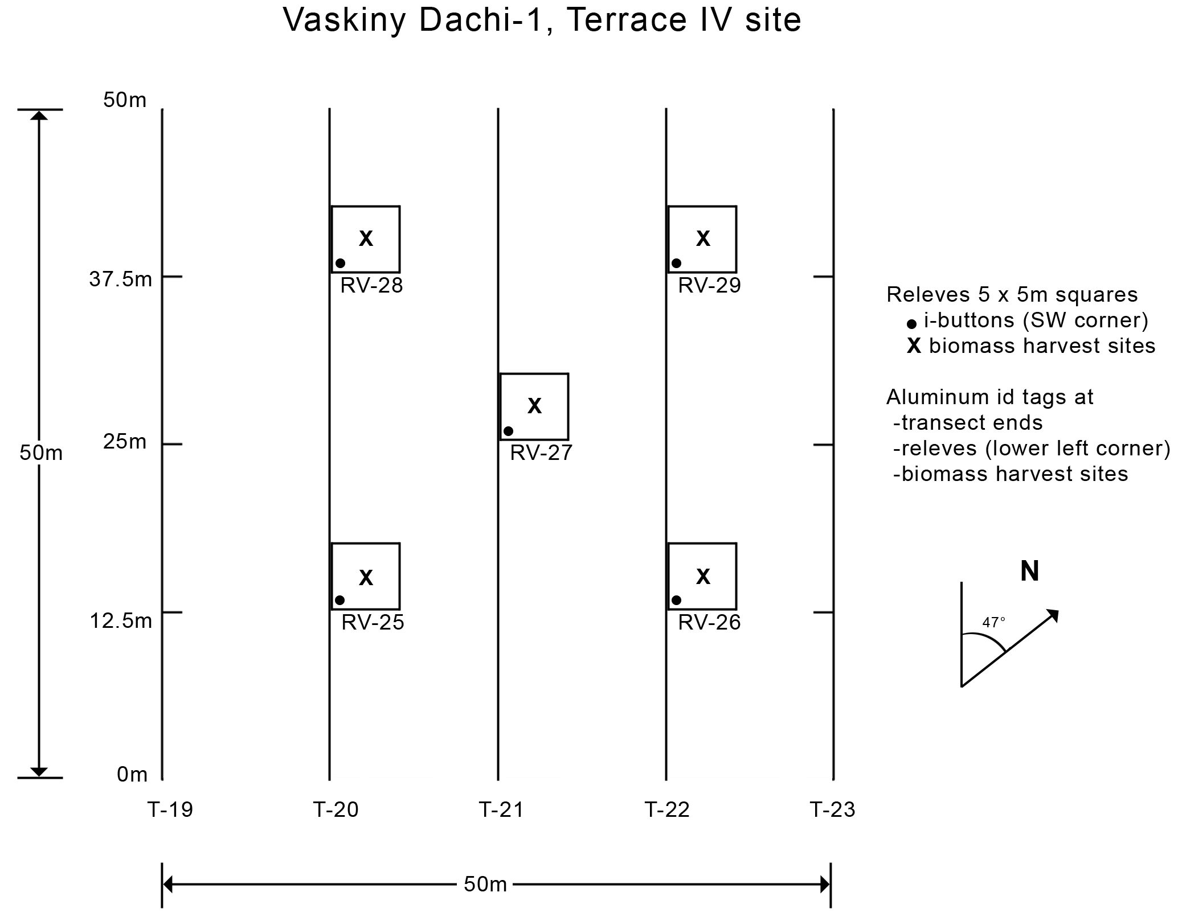
Map of transects and vegetation study plots at Vaskiny Dachi-1

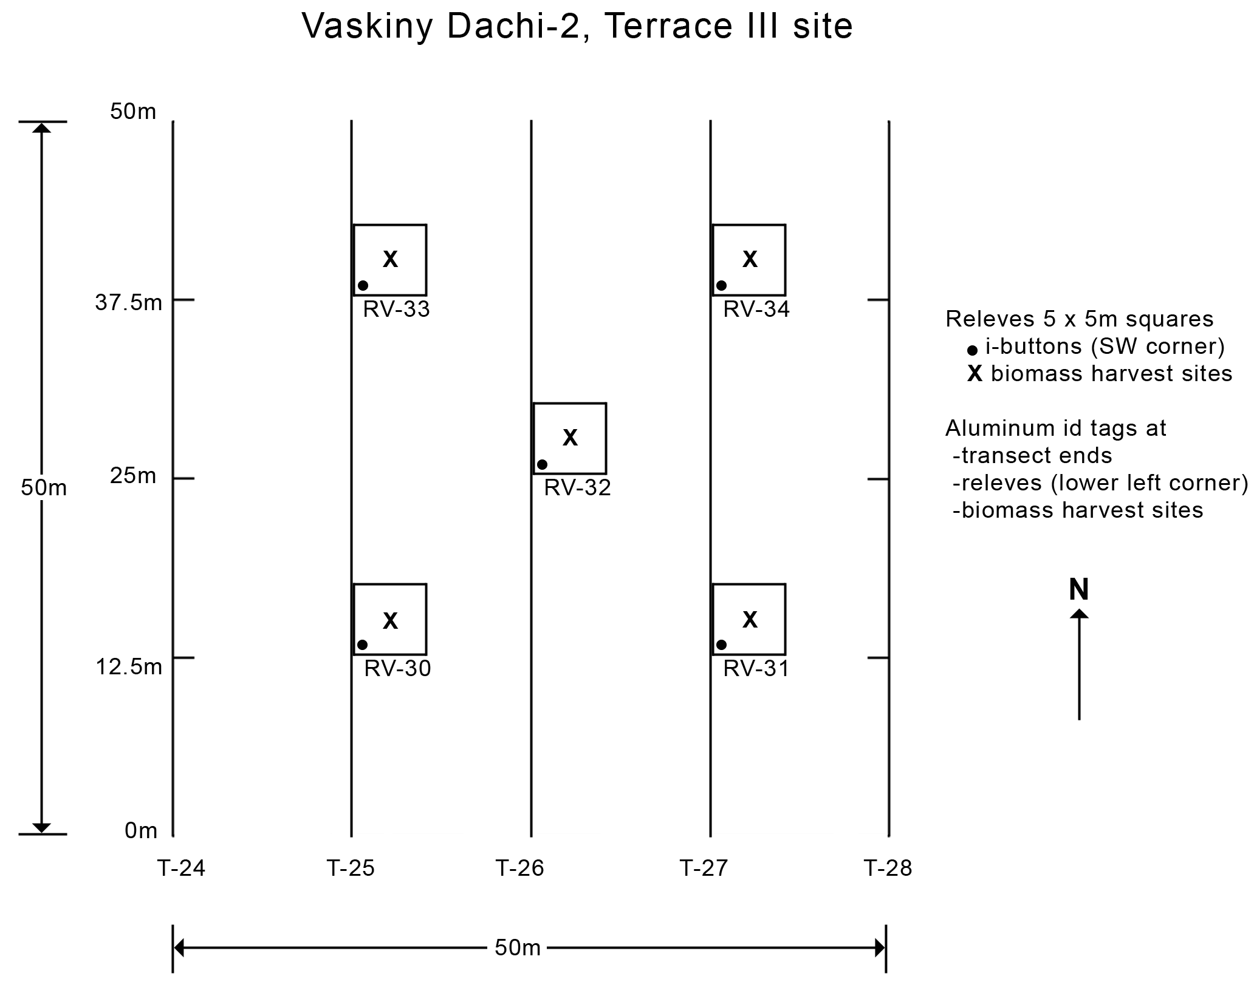
Map of transects and vegetation study plots at Vaskiny Dachi-2.

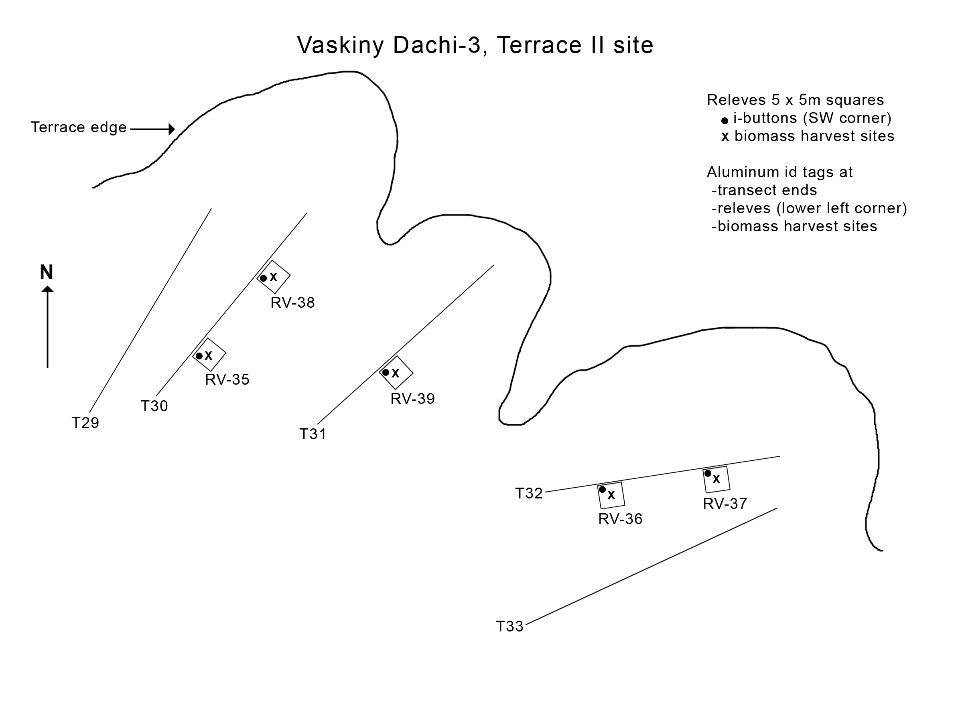
Map of transects and vegetation study plots at Vaskiny Dachi-3.

Ostrov Belyy site maps
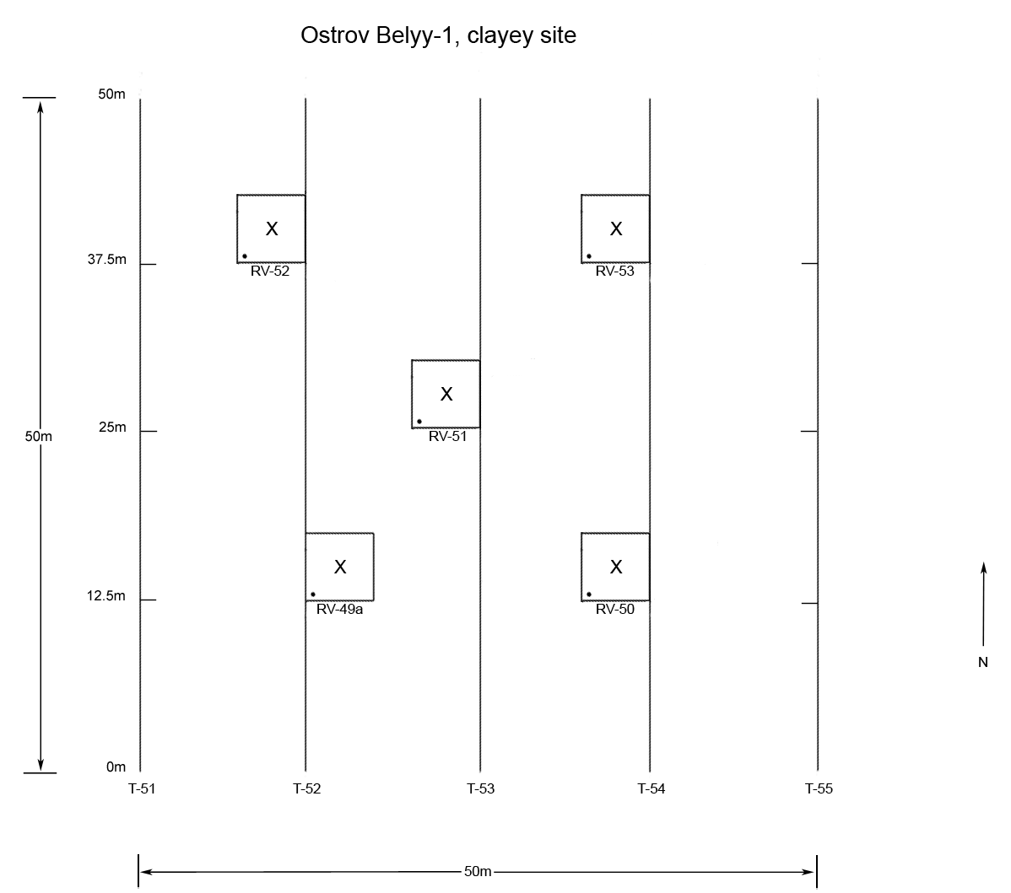
Map of transects and vegetation study plots at Ostrov Belyy-1.
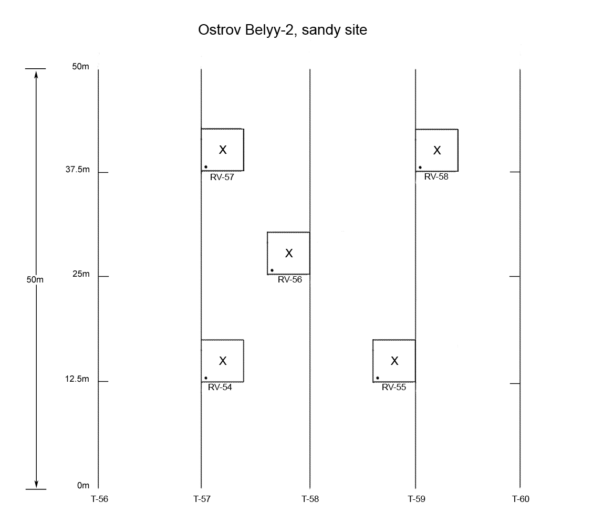
Map of transects and vegetation study plots at Ostrov Belyy-2.
Krenkel site maps

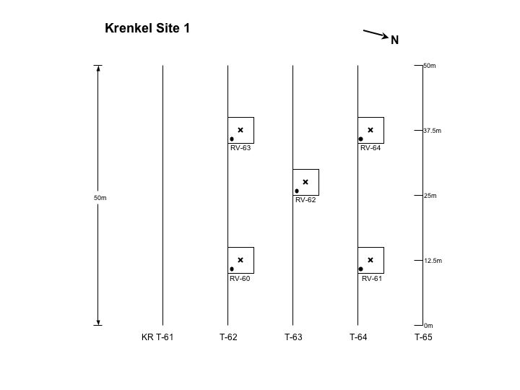

Map of transects and vegetation study plots at Krenkel Site 1. The x in the center of each plot is the location of the 20 x 50 cm biomass harvest plot. The dot in the lower left corner is the location of the iButtons. Distance between transects is 12.5 m.
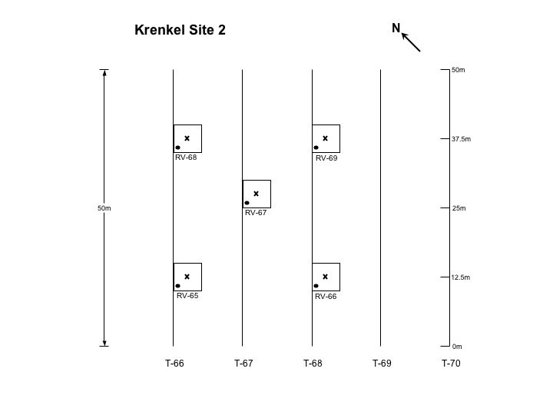

Map of transects and vegetation study plots at Krenkel Site 2. The x in the center of each plot is the location of the 20 x 50 cm biomass harvest plot. The dot in the lower left corner is the location of the iButtons. Distance between transects is 12.5 m.

